**Background/Prior Reading for School Board**

**Research on Ranges**

There is not research available that contributes to the conversation on whether or not a multi-car driving range leads to improved crash rates for teen drivers. Many studies ask if Driver Education has an effect on crash rates for drivers. So, do Driver Education programs have any impact?

In the 90s and early 2000s, formal evaluations of U.S. high school driver education programs indicated little or no reduction in crashes per licensed driver (1, 2). Other school-based programs, such as those intended to reduce alcohol-impaired driving, have not been shown to be effective, at least in the short term (3). There is evidence that skid control training and other kinds of advanced skill training increase crash risk, particularly among young males (1, 4, 5). Authors of the relevant studies have suggested that young drivers trained in these skills become overconfident, leading them to take unnecessary risks.

Skid avoidance training is another type of supplemental course. Instead of teaching young drivers how to recover from a skid, it aims to show them how difficult it is to do so. Participants are taught to slow down and refrain from erratic steering and hard braking in reduced-traction situations to avoid skidding in the first place. A recent Institute study of one such course did not find consistent effects on subsequent traffic citation rates and crash risk (6).

A study evaluating hazard perception training, which aims to change a driver's awareness and perception of potential risks while driving, did not find a significant overall effect on crashes among young drivers; however, males ages 16-18 who had taken the training had a 24 percent lower crash rate relative to males in the control group (7).

1-Mayhew, D.R.; Simpson, H.M.; Williams, A.F.; and Ferguson, S.A. 1998. Effectiveness and role of driver education and training in a graduated licensing system. Journal of Public Health Policy 19(1):51-67.

2- Vernick, J.S.; Guohua, L.; Ogaitis, S.; Mackenzie, E.J.; Baker, S.P.; and Gielen, A.C. 1999. Effects of high school driver education on motor vehicle crashes, violations, and licensure. American Journal of Preventive Medicine 16(Supple 1):40-6.

3-Williams, A.F. 1994. The contribution of education and public information to reducing alcohol-impaired driving. Alcohol, Drugs, and Driving 10(3-4):197-202.

4-Christie, R. 2001. The effectiveness of driver training as a road safety measure: a review of the literature. Victoria, Australia: Royal Automobile Club of Victoria.

5-Williams, A.F. and Ferguson, S.A. 2004. Driver education renaissance? Injury Prevention 10(1):4-7.

6-Farmer, C.M. and Wells, J.K. 2015. Crash and citation records of young drivers with skid avoidance training. Arlington, VA: Insurance Institute for Highway Safety.

7-Thomas, F.D.; Rilea, S.L.; Blomberg, R.D.; Peck, R.C.; and Korbelak, K.T. 2016. Evaluation of the safety benefits of the risk awareness and perception training program for novice teen drivers. Report no. DOT HS-812-235. Washington, DC: National Highway Traffic Safety Administration.

**Because of this what happened?**

Because of this research, and the fact that teenage drivers continue to have the highest crash rates for all age groups, other safety measures were recommended. The result is the Graduated Driver Licensing laws. Graduated driver licensing (GDL) laws reduce this risk by making sure teens gradually build up driving experience under lower-risk conditions as they mature and develop skills. That means limiting nighttime driving, restricting teen passengers and making sure teens get lots of supervised practice. Graduated licensing has reduced teen crashes 10-30 percent on average.

All 50 states and the District of Columbia have a three-stage GDL system. The United States doesn't have a national GDL law. State lawmakers decide what provisions to adopt and how to enforce them. Institute research has show that states with the strongest laws enjoy bigger reductions in teen driver deaths than states with weak laws. Some states make teens wait a little longer before they get their learner permits and full-privilege licenses. This also saves lives.

Virginia is not the most restrictive, but it has fairly strong requirements. For more details, see this link <http://www.iihs.org/iihs/topics/laws/graduatedlicenseintro?topicName=teenagers>.

Karen has a “Road to Licensure” sheet that she has made that explains the steps in great detail. For teens under 18, Driver Education is required which includes 36 hours of classroom instruction and 14 hours of in-car instruction (7 driving and 7 observation). Virginia also has a minimum entry age of 15 and 6 months and a mandatory permit holding period of 9 months, so the earliest age for licensure is 16 and 3 months. Teens must have 45 hours of supervised driving, 15 must be at night. Unsupervised driving is prohibited for teens from 12-4am. In Northern Virginia and in Albemarle, a parent seminar is required. When teens earn a restricted license, they may have no more than 1 passenger under the age of 21 in the first 12 months after licensure. If you are 18 or older, you do not have to complete Driver Education and you may obtain a permit and hold it for 60 days before moving on to your licensure exam.

Teenage crash risk dropped significantly during the period of GDL laws, but crash risk for teenage drivers still remains high and research supports strengthening GDL laws even further.

**Another major recommendation was to change how instruction is delivered so that it is more engaging and to focus on changing attitudes and not behaviors.** The VDOE curriculum is potentially leading the nation in this change. VDOE says that the stated goal is to “create a culture of safe driving behaviors by fundamentally improving driver behavior, not just traffic safety knowledge and skills; whereby students adopt safe driving behaviors and attitudes….” (VDOE, 2017, p.5). Anecdotally, VDOE staff reports that driving ranges, whether in parking lots or in separate spaces like the AHS multi-car range, contribute to the development of safe driving behaviors by providing a controlled space away from other drivers to train. Staff liken the range to any other instructional tool that contributes to providing real-world and engaging experiences for students.

(As an aside—the curriculum explicitly makes the assumption that the Driver Education Program provides equitable access to a high quality program at a low cost and all of the teachers that I interviewed believe this. The research is pretty well established that having a Driver Education Program in the public schools is important for equity and access reasons.)

**VDOE Curriculum about In-Car Portion—Here’s what it says verbatim**

### LABORATORY INSTRUCTION

Laboratory instruction may include simulation, multiple-car-range (MCR), and on-street instruction. The average length of time a student can safely operate the driver education vehicle in complex, demanding driving situations may vary. Many teachers have found that student learning is maximized by offering two 25-minute instructional “blocks” to satisfy the minimum 50-minute requirement. Switching the two student drivers more frequently is especially effective during initial lessons when students may be nervous, anxious, or afraid. In addition, dividing the lesson into two segments allows the teacher to intensify the number of steps and complexity of the performance skills. It also maximizes learning for the observing student who immediately applies the skills and processes they observed.  
  
Instruction should begin in the school parking lot, or at the school division’s designated location, such as a multiple-car-range facility. Instruction should end at the same location unless local school board policy allows students to be dropped off at home or at another location. Teachers should coordinate with parents via text or another mode of communication when students are dropped off at home. Schools should consider installing cameras and/or GPS systems telematics in vehicles to improve safety and oversight. These systems record both the driver and the road, and provide real time monitoring of speed, location, and let administrators know when vehicles deviate from their set route.

### MULTIPLE-CAR-RANGE INSTRUCTION

A multiple-car range (MCR) enables the driver education teacher, from a position outside of the vehicle using electronic or oral communication to teach and supervise several students simultaneously each of whom is operating a motor vehicle at an *off-street facility specifically designed for this type of instruction*.Range instruction provides basic *parking lot* skills, such as steering, stopping and accelerating, backing, parking, turning and managing intersecting traffic in a safe environment. The range is also the preferred environment to provide students with simulated emergency and basic evasive driving experiences, such as blocked lane, ABS braking, hydroplaning, and off-road recovery. Learning experiences on the MCR should be offered in a sequence preparatory to and integrated with on-street driving and driving simulation.Whenever possible,however,students who have mastered “parking lot” skills on the range should “graduate” to actual on street learning experiences.The size, design, and number of vehicles used on the range will determine the types of experiences that may be provided. For example, the experiences provided on a 300’ x 500’ area utilizing 6-8 vehicles are greater than those provide on a standard range, which is 150’ X 300” with 4-5 vehicles. One period of instruction (driving or observing) on a multiple-car-range may be substituted for one period of on-street instruction (driving or observing). This one-to-one substitution ratio may be used for up to a maximum of four periods of on-street driving and four periods of observing.

### ON-STREET INSTRUCTION

Actual driving on roadways is a more valuable learning experience than simulated or multiple-car-range driving experiences. **At a minimum, students must receive at least three periods of on-street driving and three periods of on-street observing.** A minimum of two, and a maximum of three, students may be assigned in a vehicle during on-street instruction. Students may receive a maximum of two periods of classroom instruction, or two periods of laboratory instruction in a 24-hour period. Up to four periods of on-street driving and four periods of on-street observing may be replaced with any combination of simulation and multiple-car-range instruction. A period of instruction must be at least 50 minutes.

**Information pertaining to the range at Albemarle High School**

There is nothing in VA Code or VDOE curriculum requiring that a multi-car range be used; however, if schools offer behind-the-wheel, a safe space is needed for the initial assessment of students and for students to practice specific skills like off-road recovery.

VA Code: Each school board shall determine whether to offer the program of driver education in the safe operation of motor vehicles and, if offered, whether such program shall be an elective or a required course (required for us). In addition to the fee approved by the Board of Education pursuant to the appropriation act that allows local school boards to charge a per pupil fee for behind-the-wheel driver education, the Board of Education may authorize a local school board's request to assess a surcharge in order to further recover program costs that exceed state funds distributed through basic aid to school divisions offering driver education programs. Each school board may waive the fee or the surcharge in total or in part for those students it determines cannot pay the fee or surcharge (we do not have any subsidy, we used to). Only school divisions complying with the standardized program and regulations established by the Board of Education and the provisions of § [46.2-335. *Code of Virginia* Learner's Permits; Fees; Certification Required](https://law.lis.virginia.gov/vacode/title46.2/chapter3/section46.2-335/) shall be entitled to participate in the distribution of state funds appropriated for driver education.

The actual initial driving instruction shall be conducted, with motor vehicles equipped as may be required by regulation of the Board of Education, on private or public property removed from public highways if practicable; if impracticable, then, at the request of the school board, the Commissioner of Highways shall designate a suitable section of road near the school to be used for such instruction. Such section of road shall be marked with signs, which the Commissioner of Highways shall supply, giving notice of its use for driving instruction. Such signs shall be removed at the close of the instruction period. No vehicle other than those used for driver training shall be operated between such signs at a speed in excess of 25 miles per hour. Violation of this limit shall be a Class 4 misdemeanor.

No more than four periods of actual driving and four periods of observation on a multiple-car-range can count towards the 14-period in-car requirement.

A few school divisions no longer offer BTW and these are: Appomattox, Botetourt, Clark, Culpepper, Fauquier, Fluvanna, Goochland, Greene, Pittsylvania, Rappahannock, Roanoke County, Spotsylvania, York (go to NN), Alexandria, Danville, Falls Church, Portsmouth, Suffolk, Poquoson, Manassas Park.

There is no research that I could find attributing driving ranges to successful Driver Education Programs. However, the women in charge of Driver Education at the VDOE, each with over 40 years of Driver Education experience, state that having a driving range is preferred and is a best practice over the use of a designated space in a parking lot. They point to Chesterfield and Newport News as having exceptional programs. These school divisions have large driving ranges, much bigger than the one at AHS. Vanessa Wigand states that, “It would be a huge loss because that is one of the better programs in the state.” I also spoke to Jard Schumake from Fairfax County Public Schools. There are 26 high schools in Fairfax County, but they do not all have designated spaces. Some students must go to a nearby high school for training. He commented that having the multicar range is a best practice and “it would be a shame” to lose it for students and the instructors.

All of the staff who instruct, or have instructed, the behind the wheel portion indicate the importance of the range. AHS uses the range to assess driver’s skills and to pair up drivers for behind-the-wheel training. For community use, senior drivers are assessed on the range to determine their fitness to continue driving, and adult drivers are assessed on the range before beginning anycourse. Additionally, the Cub Scouts offer an annual Bicycle Safety course. Western Albemarle uses their designated range for the first 30 minutes of each “day” of instruction. Albemarle High school uses the multi-car range for the first two days of instruction which consists of 4 hours and for part of the driving test on the last day. Monticello also uses their designated space in the same as AHS. Because the program is offered before school, after school, on the weekends, during the school day, and in the summer, the multi-car range at AHS is in use several days out of every week.

**If the range is taken away, where would it be relocated?**

Western has a range located behind the school and it doubles as a bus parking area and a school bus training area. It is marked with white lines for driver training and also yellow lines for bus parking. There is a small range tower for multi-car use. This means that an instructor will sit in the tower or be on the range while students are driving in the designated space. The students have walkie talkies to hear the instructors commands and another student in the car observing. They are able to coordinate training around the school bus departures in the afternoon with some difficulty. They offer some training during the school day, but they have very limited staff to do so. Cars are parked in designated spaces behind the school and close to the tower.

Monticello High School has a designated range space in the front of the school that doubles as the bus lot. It is not marked and the instructors must set up cones each time that it is in use. This is challenging because of the time it takes to do so and because people view it as other things (namely, the bus loop or a parent drop off area) rather than the driving range. Monticello does not have a tower and it is not very secure, being in the front lot. Driver Education cars are parked there and there are concerns about the security of them.

Albemarle High School has the designated space that is the multi-car driving range located near Jouett. It is fenced in and houses 14 Driver Education vehicles. The tower on-site also doubles as the office space for most of the Driver Education staff and as storage. The lower floor of the tower has potential for development of a VR lab to provide simulation training. The layout and current usage of AHS makes it challenging for an alternative range placement. The way that the front parking lot is laid out, the amount of traffic, and the proximity to Building Services and LEAD makes it difficult to repurpose any of the front lot for Driver’s Education instruction. The back parking lot might work as an alternative if it was painted and designated, but probably not in its current state.

I interviewed Dr. Turner to ask what the impact would be on his program if the multi-car range was taken away and moved to another area. He spoke about the blue ribbon fine arts/band program at AHS and said that moving the range would certainly impact this program. I asked him to compare MOHS and AHS in terms of the behind the wheel instruction and he stated, “What we did with my teachers setting up cones is no comparison to what the kids get with the range. We are always talking about real-life learning opportunities. Why would we take away that learning opportunity for students or minimize the instruction? We do it like that at MOHS because we can’t do any better. It’s a real-life classroom. It’s the same as other classes—want them to be in the real environment, like a real kitchen for culinary, etc.”

When asked for his opinion if the range was not rebuilt, he stated, “I would hate to see it go. Teenage drivers are typically the worst drivers, we can give them the best and most sound driving instruction with the most sound instructional tools…to take that away…to take that experience away from students, I would not want to see more accidents involving my children because their driving instruction was lowered in quality. Range is being used—so why would we take it? I can see if we were getting rid of it for a county program….”

**State and Local Crash Statistics and Program Quality**

I interviewed Vanessa Wigand and Janet Ragland from VDOE who both stated that Albemarle has a quality program with outstanding instructors and consistently “above average” crash statistics. I spoke with Dr. Vonnie Colvin from Longwood University who trains Driver Education instructors and she also commented on the quality of our staff as well as our training.

**DRIVING SCHOOL COST & CRASH RATE COMPARISON USING MOST RECENT CRASH DATA 2015-16**

|  |  |  |  |  |
| --- | --- | --- | --- | --- |
| **SCHOOL NAME** | **PRICE** | **2015-16 TOTAL STUDENTS** | **2015-16 CRASHES** | **2015-16 CRASH PERCENTAGE**  **RATIO** |
| Albemarle Driving School LLC  6506 Woodbourne Lane  Crozet | $275.00 | 69 | 5 | 7.25 |
| Augusta Defensive Driving School  1025 B. W Main St  Waynesboro | $325.00 | 152 | 7 | 4.61 |
| Charlottesville Academy of Driving  3462 Scottsville Rd  Charlottesville | No Data | 83 | 5 | 6.02 |
| Green Light Driving School  1924 Arlington Boulevard  Charlottesville | $350.00 | 306 | 15 | 4.9 |
| **Albemarle County Schools Community & Driver Education** | **$300.00** | **311** | **11** | **3.5** |
| **Charlottesville High School** | **$175.00** | **117** | **6** | **5.13** |

* Bold type denotes public schools
* Commercial School State Average Crash Ratio: 5.00
* Public School State Average Crash Ratio: 4.58



Program, Participation, Outcomes Comparison

**Programs**

|  |  |  |
| --- | --- | --- |
| **Albemarle** | **Monticello** | **Western Albemarle** |
| Secured Multiple car driving range in its own space with range tower, storage, vehicle parking space | Parking lot with cones, must be set up for each use; costs more for staff for set up of range (time) | Multiple car driving range with painted lines (not secured) in back parking lot with range tower and parking spaces |
| 9 Teachers: 4 classroom, 3 In Car only, 2 classroom/In Car | 5 Teachers: 1 classroom, 3 classroom/In Car, 1 paraprofessional (In car only) | 6 Teachers: 1 classroom only, 3 classroom/In Car, 2 paraprofessionals (can only teach in car) |

**Participation In Car Instruction During the School Year**

|  |  |  |  |
| --- | --- | --- | --- |
| **Year** | **Albemarle** | **Monticello** | **Western Albemarle** |
| 2015-16 | 109 | 130 | 81 |
| Summer 2015 | 31 | 16 | 14 |

**Crash Rate Each School as Reported by VDOE**

|  |  |  |  |
| --- | --- | --- | --- |
| **Year** | **Albemarle** | **Monticello** | **Western Albemarle** |
| 2015-16 | 3.59 | 4.35 | 3.23 |
| 2014-15 | 5.26 | 3.64 | 2.67 |
| 2013-14 | 5.97 | 4.72 | 1.05 |
| 2012-13 | 4.9 | 0 | 1.8 |
| 2011-12 | 5.86 | 2.31 | 4.35 |

**Fees**

The Driver Education Budget has not been thoroughly reviewed. However, student charges have gone up because the State Reimbursement has gone down the last few years. From 2009-2014, the state reimbursed approximately $65 per student. The past two years, the state has only given approximately $35 per student. Subsequently, in recent years the amount charged has increased for students.

Staff reports that the Driver Education Program used to offer $50 towards student fees for students who were in the free and reduced price lunch program. This ended under Rick Wharam due to lack of finances. Karen has actively been trying to secure scholarships for students under her tenure and recently secured a grant from State Farm that will assist approximately 16 students with 50% scholarships. (The number will grow as more contributions are made, but the initial grant was $2500.)

Google Maps Images of spaces

AHS Range

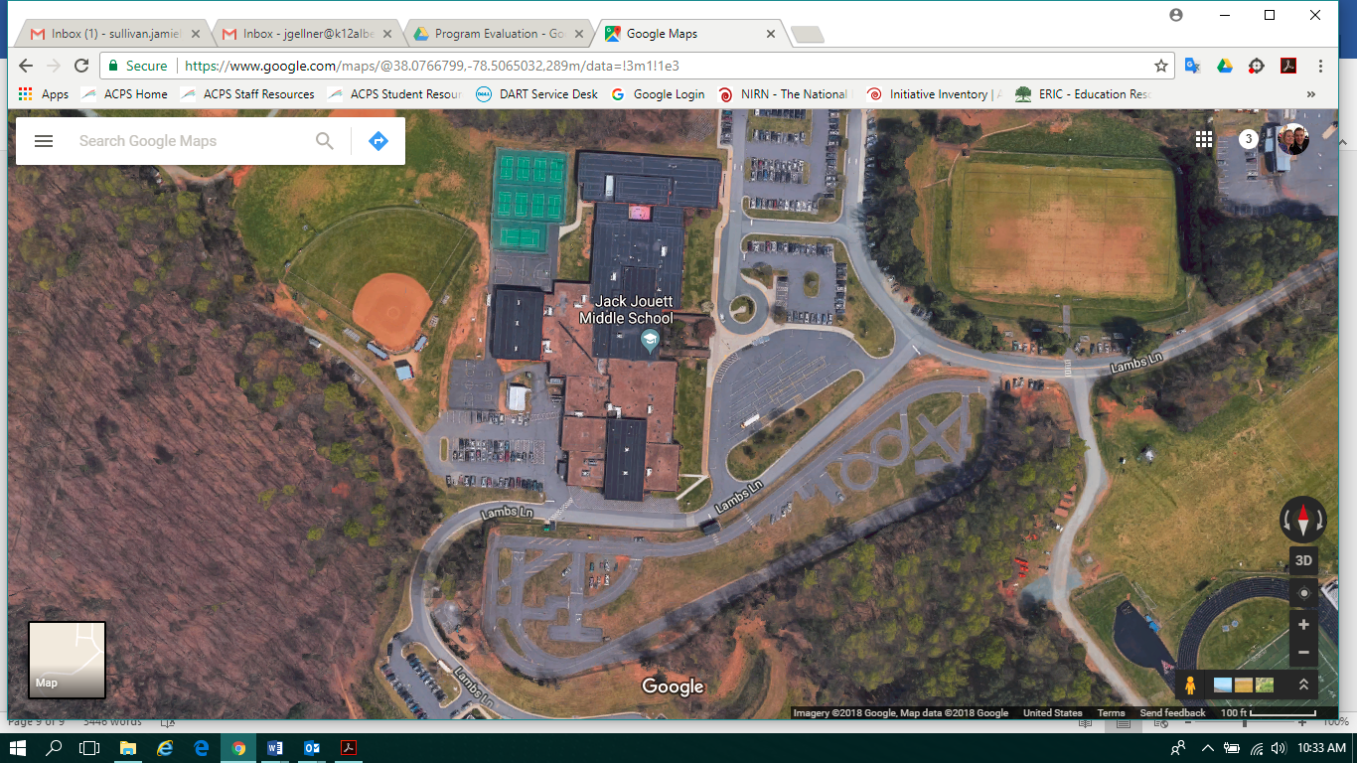

WAHS

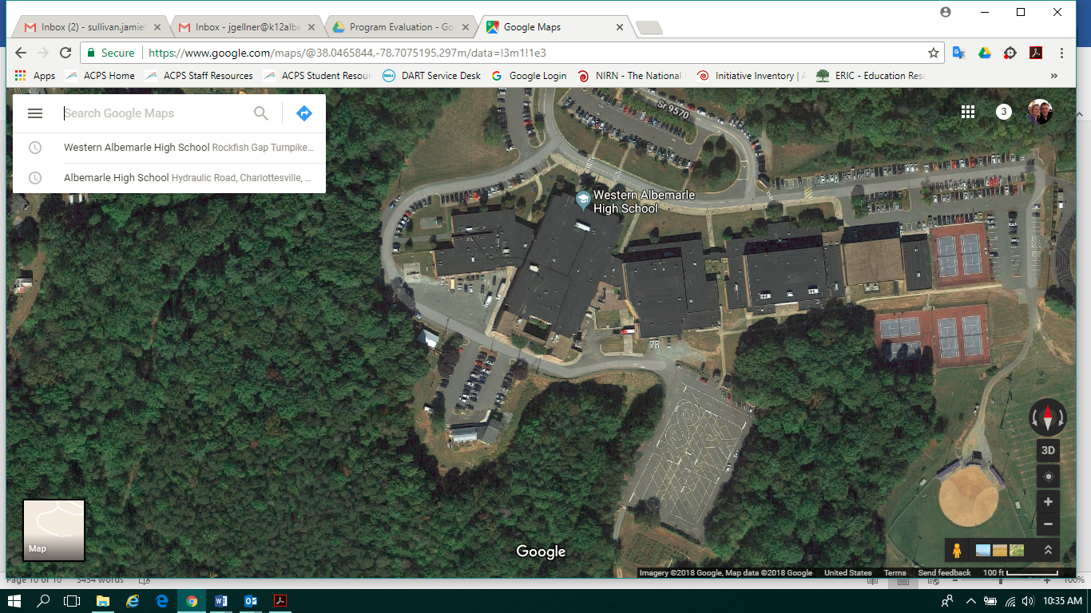

MOHS

