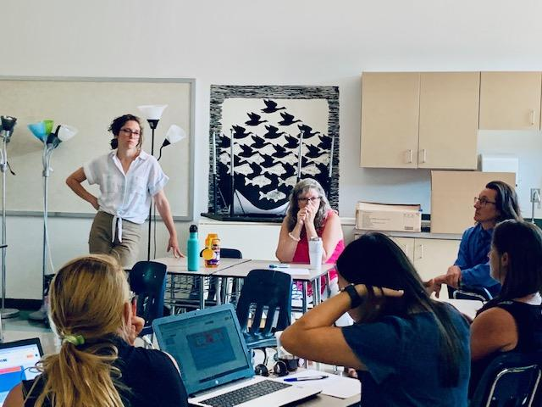
Introduction
Over the past seven years, the Albemarle County Public Schools Culturally Responsive Teaching (CRT) program has significantly impacted the professional development and growth of many educators and students across the division. From grassroots development with a few educators in 2015 until now, our mission remains the same, “To build collective efficacy around Culturally Responsive Teaching to increase equitable outcomes for all students.”

This report shares our program's achievements and next steps. As a relatively young program with a high potential to change academic results for all students, it has been essential that we set clear goals, measure progress, and transparently report program impact as we move continuous improvement forward.

This report only tells part of the story. It cannot capture its most lasting effect—educators creating learning environments accessible to all students and families, especially those historically marginalized. The data tells us it is the best path forward if all students are to be successful and the beneficiaries of our division’s world-class opportunities.

Program Overview

Our Culturally Responsive Teaching Program was developed by a small group of passionate educators seeking new ways to address the persistent equity gaps for our racially and linguistically diverse students. Since its inception in 2015, the program has evolved from training and certifying four teacher leaders to 150 teachers. It equips another 219 educators with the first step towards certification, earning a micro-credential in CRT. These educators represent a variety of roles, including but not limited to central office staff (including the superintendent), building administrators, instructional support staff, classroom teachers, safety coaches, and teacher assistants.

Over two decades ago, Gloria Ladson-Billings introduced the term Culturally Relevant Pedagogy to describe a form of teaching that calls for engaging learners whose experiences and cultures are traditionally excluded from mainstream settings. Based on her research of effective teachers of African American students, Ladson-Billings proposed three goals on which these teachers’ practices were grounded based on her study of effective teachers of African American students

Building on the work of Ladson-Billings, Geneva Gay, developed a framework with a stronger focus on teachers’ strategies and techniques—that is, the doing of teaching. Gay coined the term culturally responsive teaching.

These scholars promote asset-based approaches as alternatives to popular deficit-oriented teaching methods, which position the languages, cultures, and identities of students as barriers to learning.

Zaretta Hammond draws on cutting-edge neuroscience research to offer an innovative approach to designing and implementing brain-compatible, culturally responsive instruction.

Anchored in the study of Geneva Gay, Gloria Ladson- Billings, Glenn Singleton, and Zaretta Hammond, the ACPS Culturally Responsive Teaching Framework and 3 Characteristics were developed.

Though this program is not aligned with the federal standards of “evidence-based practice,” it is critical that we prepare educators to work with culturally, linguistically, ethnically, and racially diverse students, especially in light of the annual ACPS SOL and Panorama data which consistently show a long-standing opportunity gap for these students.

The ACPS CRT program considers the intentionality and use of evidence-based, high-quality teaching practices, data analysis, the development of trusting relationships, and an understanding of how implicit biases impact our students. In doing so, we can expect to improve learning for all our students, specifically those who need it most.

The outcomes from the classrooms of 37 certified and 36 micro-credentialed educators between 2017-2019 reported the closure of achievement gaps through their CRT assessment and documentation of impact. The Cale Elementary (currently Mountain View) school-wide CRT training noted some compelling data trends.
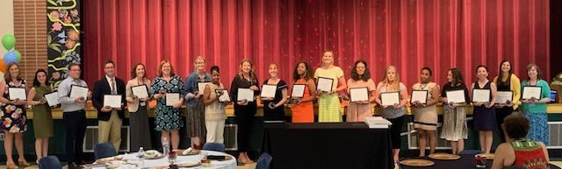

At its core, CRT is made by teachers, for teachers, and celebrates their wins, culminating in an annual equity conference. Educators uplift and share their research at the conference after it has undergone a rigorous assessment process. Credentialed educators are honored and awarded by their peers. Embedded in the program is the leadership of these educators who give back to their school community as peer mentors and through leadership development.

By the 2019-20 School year, the division's credentialing process shifted from a “small” passion-driven pilot program to an opportunity for all educators to participate in a “Community Conversation,” a professional development program that provided a broader understanding of the CRT program model to the entire school community. This program led 206 educators to begin their journey toward earning their credentials. Even though schools across the nation were shut down due to the spread of Covid-19, the number of division CRT candidates earning credentials increased by 27 percent. Many educators also attributed their success with students during the shutdown to their CRT training.
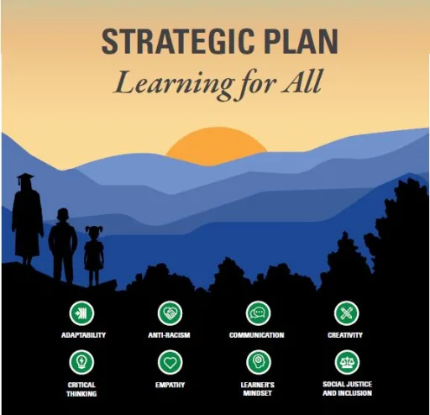
In August of 2021, the ACPS School Board approved the current Strategic Plan, “Learning for All,” which includes Goal 2:
ACPS commits to developing a culturally-responsive environment that will respect and champion the diversity of life experiences of all stakeholders and supports the physical and mental health of our students, staff, and families, so they are actively empowered to engage in our school community. This goal includes the provision that all classroom teachers and school administrators will obtain at least an ACPS Culturally Responsive Teaching Micro-Credential by 2026.

This validation implies “strong” evidence of the effectiveness of the ACPS Culturally Responsive Teaching program by the School Board and community.
Additionally, in March 2021, the Virginia Board of Education approved new guidelines for the Uniform Performance Standards and Evaluation Criteria to include:

Performance Standard 6: Culturally Responsive Teaching and Equitable Practices*
The teacher demonstrates a commitment to equity and provides instruction and classroom strategies that result in culturally inclusive and responsive learning environments and academic achievement for all students.
To fulfill these directives, the program underwent its first phase of revisions to meet the needs of educators by
- Updating the CRT Framework to align with the Educator Performance Appraisal Standards closely;
- Differentiating learning pathways through school-based and division-level cohort models;
- Differentiating the assessment process to provide multiple options to show and share action research and results;
- Providing timely feedback with an optional February pre-submission review;
- Offering individual coaching sessions and personalized school-based professional development; and
- Implement a continued learning (rolling submission) model for candidates who have not fulfilled the assessment criteria.
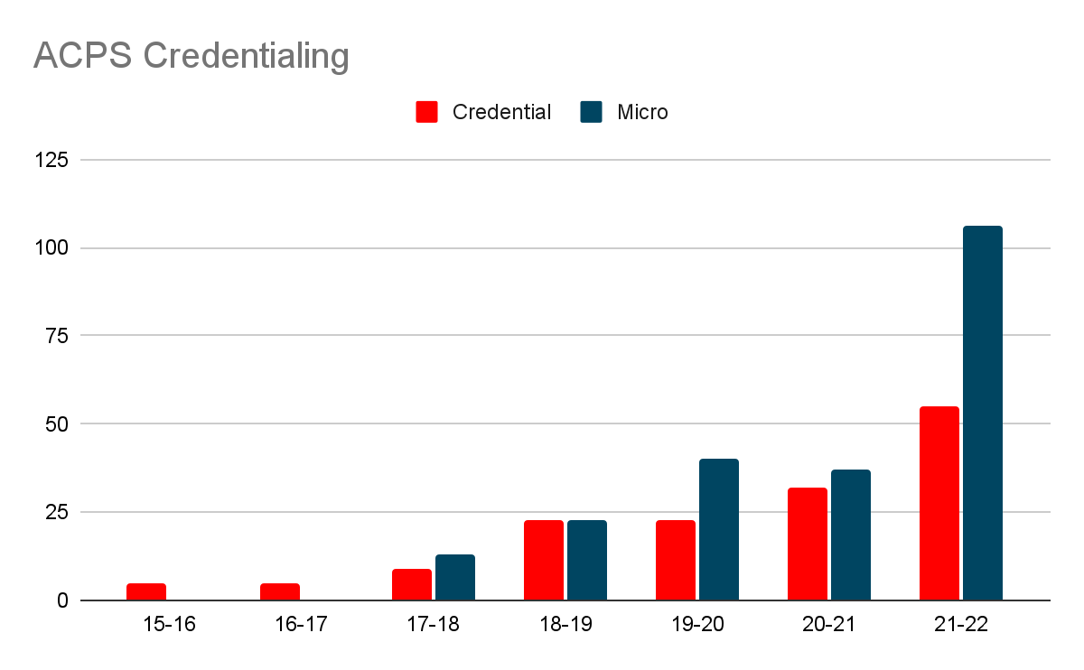
These adjustments increased access and opportunities for the diverse needs and representation of staff and educators engaged in this process. Between the 2020-2022 school years, 88 educators obtained a complete certification, and 146 obtained a micro-credential despite COVID, school shutdowns, virtual learning, and the countless ongoing challenges our students and staff experienced.

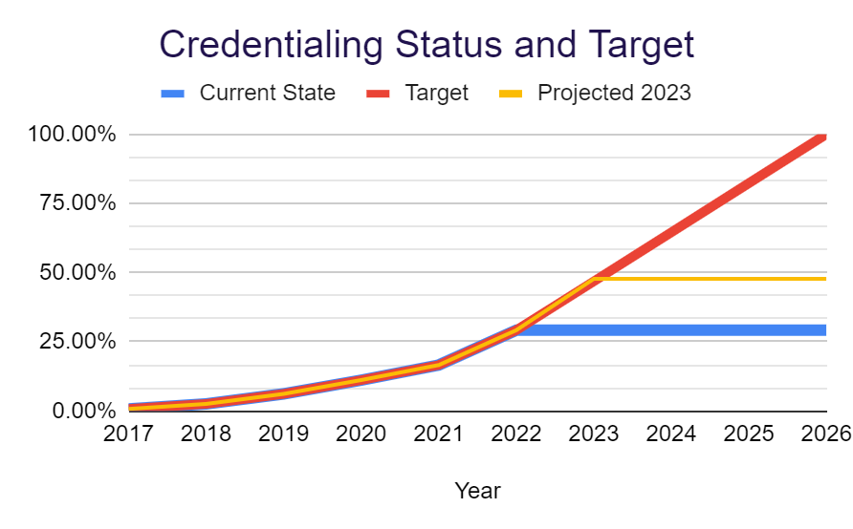
Phase II
Our work continues. To date (2022-2023 SY) the program has credentialed 341 educators from a cross-section of the school division. Of these educators, 57 have moved out of the division to take on new roles and opportunities. Additionally, 20 have been promoted to key leadership roles within the school division since receiving their initial credential. To end the predictive value of race, class, gender, and special capacities for our children’s success through high-quality teaching and learning for all,” approximately 260 educators (per year) will need to complete the current micro-credential requirements to meet the 2026 goal set by the school board. To meet and exceed this goal, ongoing program revisions will be required, as well as targeted implementation at our most vulnerable schools, including Woodbrook Elementary, Agnor Hurt Elementary, Mary Carr Greer Elementary, Mountain View Elementary, Scottsville Elementary, Red Hill Elementary, Journey Middle, and Burley Middle.*

2022-23 Improvement Plan and Goals
After a close analysis of the ACPS Culturally Responsive Teaching by a variety of stakeholders during the 2021-2022 school year, several long and short term program challenges and opportunities were identified. The following short-term goals were identified for the 22-23 school year.
- Clarified program expectations (requirements, application, data collection, timelines)
- Accessible and timely resources and exemplars
- Streamlined professional development
- Closer alignment to instructional practice
- Differentiated professional development for non-classified staff
- Differentiated credentialing assessment process
- Align resources to address equity gaps in most impacted schools.
Long-term goals will be shared later in this report.
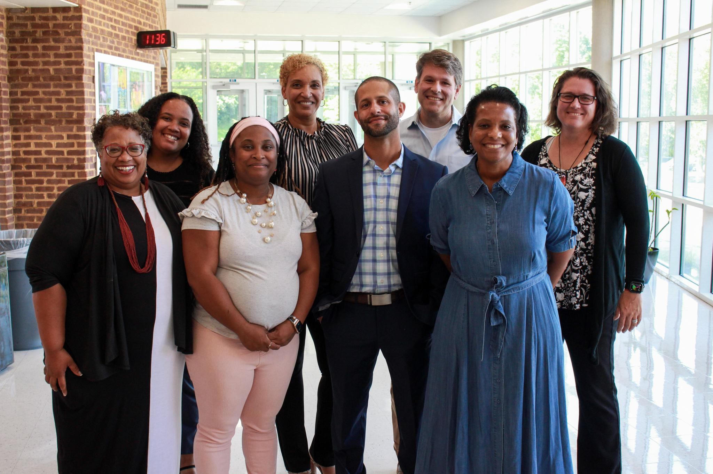
2022-23 ACPS Culturally Responsive Teaching Program Updates
While the programming shifts stated above are expected to be implemented, it is with new Department Leadership and Equity Specialists at the forefront of this work. For this reason, some anticipated changes are part of a transition plan to some ultimate long-term program shifts.
To equip educators with the tools, resources, and knowledge necessary to be credentialed Culturally Responsive Educators with sustainable practices and learning opportunities for years to come; embedding practices in Professional Learning Community (PLC) meetings, standards-based lesson plans, and design, and providing consistent support and feedback will be necessary. The first steps towards this goal are
- Lead coaches and Equity Specialists will collaborate to support the monthly division leveled Professional Learning Community meetings and Instructional Coaching Clusters.
- Director of Equity Education and Specialists will attend weekly Lead Coach meetings “as needed.”
- Equity Specialists will provide monthly articles in the Division Compass to highlight celebrations, a spotlight on CRT educators and their practice, and professional learning opportunities for all staff.
- Equity Specialists will work collaboratively with Building Administrators to support school improvement planning and goal setting.
As we work as a team to close the achievement gaps, differentiated learning opportunities, streamlined programming, and clarity of expectations will be at the forefront of change.
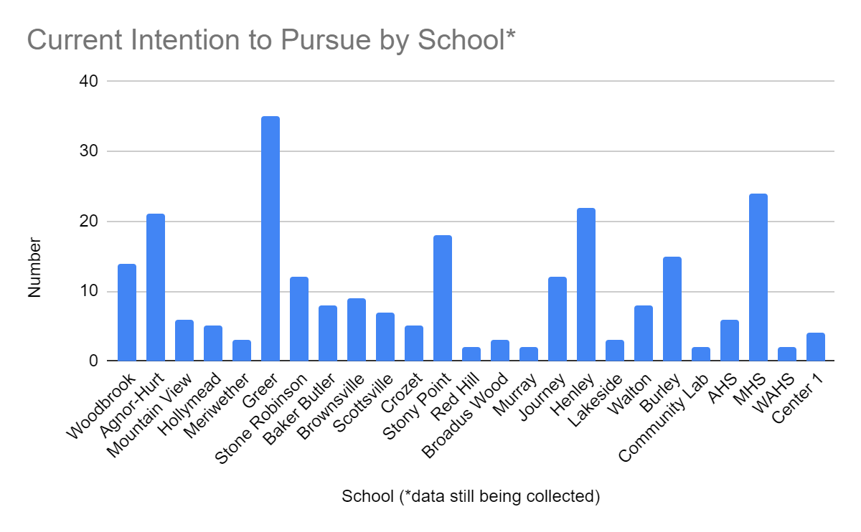
This includes recognizing and supporting the educators who have been working towards credentialing for the past three years while transitioning through the school closings and virtual learning by providing expedited learning and submission opportunities for the CRT and The Brain book study, asynchronous module training of the three characteristics and an expedited assessment submission in January 2023.
All educators have an opportunity to choose the learning and assessment pathway that works best for them. As of October 2022, 243 educators have indicated an intention to pursue and complete credentialing through one of the following pathways. An additional 25 would like to use this as a learning year.
Choice 1: CRT Learning Year: participate in a 10-week CRT and the Brain book study to receive fundamental learning of Culturally Responsive Pedagogy of the ACPS Culturally Responsive Teaching Practice. Candidates may choose to attend monthly cohort meetings for continued learning and practice.
Choice 2: CRT Micro-Credential: Participate in the CRT and The Brain book study, complete an Equity Audit and attend cohort meetings to learn about the application of practice and data collection for one characteristic of the ACPS CRT Framework. Submit a 5-7 page product reflective of professional learning, application of practice, and growth data associated with the CRT action research plan associated with their role. Prerequisite: Equity Audit and action research plan approved by Equity Specialist or Director
Choice 3: CRT Certification: Participate in the CRT and The Brain book study, complete an Equity Audit and attend cohort meetings to learn about the application of practice and data collection for all three characteristics of the ACPS CRT Framework. Submit a 10-15 page product reflective of professional learning, application of practice, and growth data associated with the CRT action research plan associated with the role. Prerequisite: Equity Audit and action research plan approved by Equity Specialist or Director
** Candidates who do not meet the criteria for completion at the time of submission can resubmit missing components upon approval of the Directors or Assistant Superintendent of Community Engagement. Candidates must receive a referral from an Equity Specialist to resubmit action research products.

Learning Year Pathway | Credentialing  Pathway | Expedited Submission  2022-2023 School Year Only
Choose a Book Study Session | Choose a Book Study Session | Previously completed a Book Study or CRT Module Training
Attend CRT Cohort meetings  October-December (application of learning) | - Attend CRT Cohort meetings  October-December (application of learning)  - Attend CRT Cohort meetings  January- May  (application and documenting impact) | Option 1: Attend cohort meetings  Option 2: Attend a CRT Early submission workshop
Attend CRT Cohort meetings  January- May  (Application and Documenting impact) | Choose a submission option: Micro credential or Certification  Submit: Prerequisite products for feedback and review  Submit: Capstone submission and assessment | Submit an expedited Micro credential or Certification  *Specific pre-qualifications required and approval from director or specialist.
Supporting candidates to be successful includes providing timely, accessible resources and product samples. Now candidates can utilize Schoology as a part of the CRT program. Each candidate will access recordings of the book studied and monthly cohort meetings (elementary or secondary), cohort resource slide decks, and follow-up activities they can access as a member of our Culturally Responsive Teaching Program Cohort. Products and resources are differentiated to reflect a variety of educational roles. Also included are clear pacing guides to help candidates self-assess their learning and readiness for submission.
In addition to increased visibility and access to our program for all candidates, educators and community members can visit the ACPS Office of Community Engagement Website to learn more about the ACPS Culturally Responsive Teaching Program.

Micro-Credential 2023 | Certification 2023 | Extended Learning and Certifications
Attend a 10-week CRT and The Brain book study | Pre-requisites: book study | Additional Certifications are available for any Micro-Credentialed or Certified Educator
Complete monthly, virtual, credential cohort meetings (9 total)  Each Monthly PL includes learning and application of Characteristic indicators. | Complete monthly, virtual, credential cohort meetings (9 total)  Each Monthly PL includes learning and application of Characteristic indicators | Attend training and/or workshops associated with continuous learning and certification.  Examples:  -Courageous Conversations About Race  - Making Connections (Division PD Day) CRT/ Equity focus  - Culturall Responsive School Leadership Book Study  - Equity and Opportunities Fair
Micro-credential awarded after attending professional development and submitting a 5 page paper or equivalent product focused on application of 1 CRT Characteris | Certification awarded after attending professional development and submitting a 10-15 page paper or equivalent product, and panel presentation sharing application of all 3 CRT characteristics. | Facilitation and project teams:  Candidate- CRT and The Brain book study  Presentor- Equity and Opportunities Fair  Presenter- Making Connections  Facilitate CRT Credential Cohort Meetings
Candidates earn up to 45 PD Points and  $500 stipend upon successful submission  - Up to 15 pt. For cohort meetings  - 15 points for Book study  - 15 points for submission | Candidates earn up to 90 PD Points and  $1000 stipend upon successful submission  - Up to 15 pt. For cohort meetings  - 15 points for Book study  - 55 points for submission  - 5 points for conference presentation | Facilitators will be awarded PD points associated with professional learning  Stipends: Facilitator $52.00 per hour

Phase III
The next phase suggests shifts in the division calendar, resources, and programming, but it holds more opportunities for the program staff, candidates, and school division. The long-term goals of the program include:
- Time provided during division professional learning days to participate in CRT Professional Development Cohorts and Book Studies. (Candidates will only receive PD points with no stipend)
- Extended certification opportunities for credentialed educators. (Certified Facilitator, Certified CRT Peer mentor/coach, etc.)
- Using regular division provided professional development time to provide learning opportunities with follow up activities designed to culminate in an educator’s final submission, rather than focusing evaluation exclusively on a final product.
- Create more opportunities for individualized assessment timelines by providing opportunities for different levels of engagement depending on where candidates find themselves in the process and multiple submission windows for final products.
Moving forward, Increased transparency, timely support during contract hours, and self-selected pacing and research will allow for more meaningful and profound results for students and staff. This also engages many educators by providing more significant opportunities, time, and support to develop the cultural competencies on the EPA Standard 6.

Gloria Ladson-Billings, “But That’s Just Good Teaching! The Case for Culturally Relevant Pedagogy,” Theory Into Practice, 34, no. 3 (1995): 476; Gloria Ladson-Billings, The Dreamkeepers: Successful Teachers of Black Children (San Francisco, CA: Jossey-Bass, 1994); Gloria Ladson-Billings, "‘Yes, But How Do We Do It?’ Practicing Culturally Relevant Pedagogy," in Julie Landsman and Chance W. Lewis, eds., White Teachers/Diverse Classrooms (Sterling, VA: Stylus Publishers, 2006): 162–177; and Gloria Ladson-Billings, “Toward a Theory of Culturally Relevant Pedagogy,” American Educational Research Journal 32, no. 3 (1995): 465–491, source.
Geneva Gay, Culturally Responsive Teaching: Theory, Research, and Practice (New York: Teachers College Press, 2010), 31.
Jenny Muñiz, “Culturally Responsive Teaching, A 50-State Survey of Teaching Standards”, article( 2019) source

